

DBMS PROECT

TITLE - BANKING SYSTEM

Team members-

1)Sujay Gad PES1201700177

2)Mayur R Baggan PES1201700714

3)Jnanesh D PES12017001822

Introduction-

Our database is based on banking system. The database stores records of various employees ,customers ,accounts ,loans in various branches of a particular bank. The database stores and provides information in a systematic about all the attributes associated with a bank.

Purpose and Application of Database-

Banking system database can be used to compare performances of various branches in different aspects such as in which branch maximum business was done, Number of loans given to customers in a particular branch every year from 2011-2015.Database can also be used to compare various aspects of Employees working in different branches. From the information available in the database we can find out in which branch many loans,accounts are being created so that we can open up another branch in the same locality/city.

Miniworld-

The miniworld /universe of discourse for banking database is set of branches of a particular type of a bank located in various locations. Database stores information about various branches along their locations. Information is also stored about the Employees working in all these branches. Customer information along their respective accounts/loans details are also maintained in the database. The database also stores info about about various departments of a branch along with their respective locations inside the branch. Various type of analysis can be done with the help of data stored in the system.

Actions which can performed

On the database-

Insertion-

1)Each time new branch is opened info about that branch is stored in the branch table.

2)Whenever Customer takes a loan a new tuple is inserted into loan table.

Retrieval-

1)Names, age of all Employees having salary greater than 50k can be retrieved from the Employee table.

2)Names of all customers who have fixed deposit can be retrieved from account table.

Update-

1)Suppose a particular branch has shifted to a different locality than its location has to be updated in the branch table.

Delete-

1)If an Employee quits his job than his details are deleted from the Employee details since the information is no longer required.

**ER DIAGRAM**

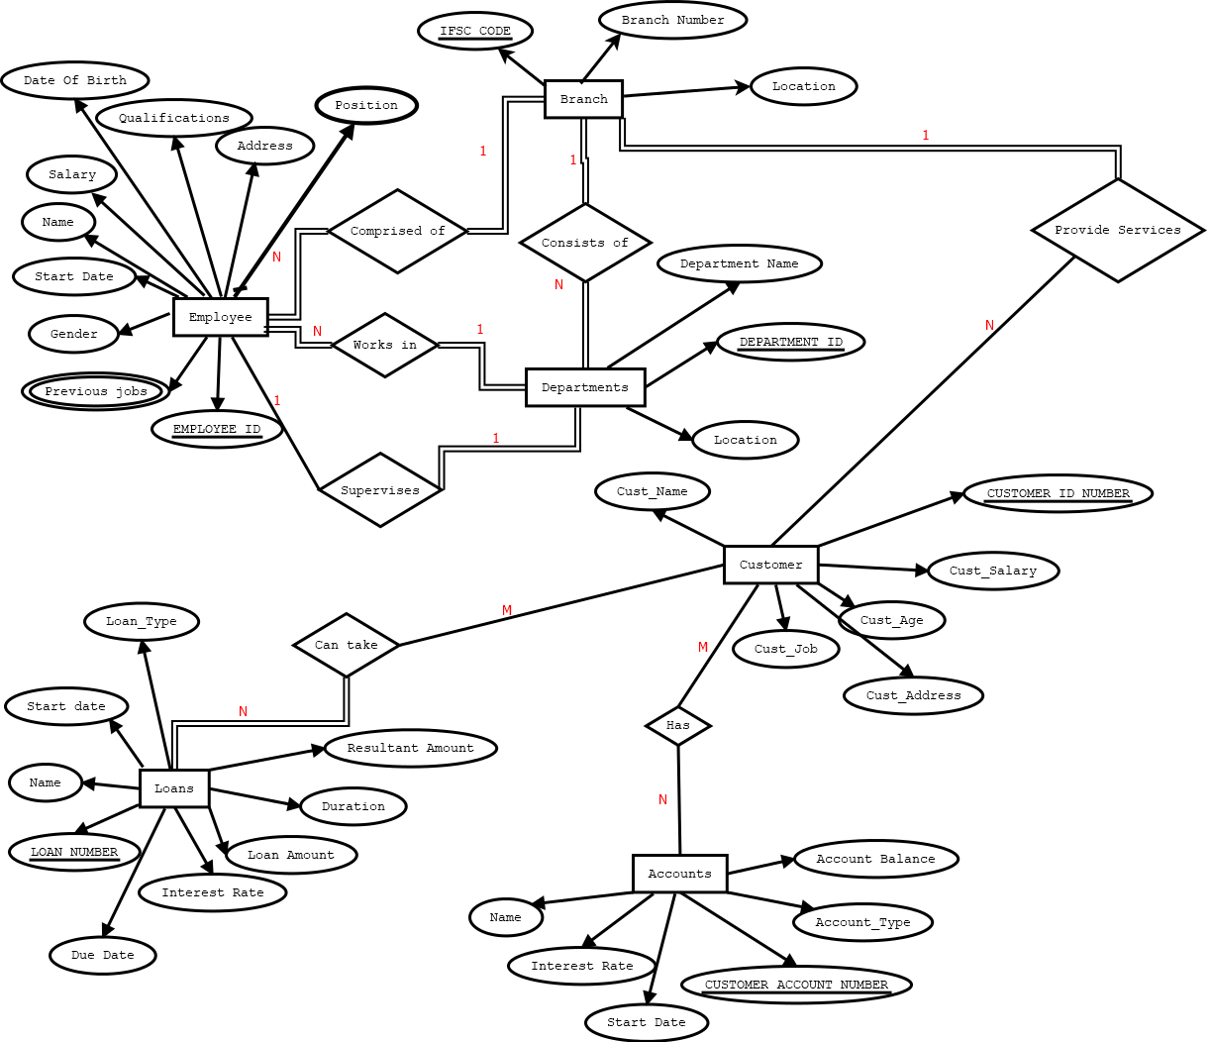

Schema Diagram

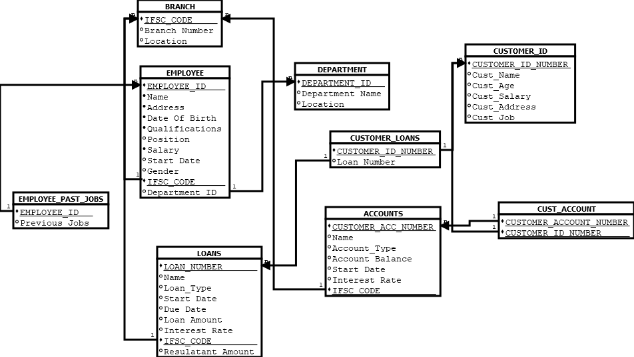

Create table statements

CREATE TABLE BRANCH

(

IFSC_CODE CHAR(11) NOT NULL,

Branch Number INT NOT NULL,

Location VARCHAR(30) NOT NULL,

PRIMARY KEY (IFSC_CODE)

UNIQUE(Branch Number));

CREATE TABLE EMPLOYEE

(

EMPLOYEE_ID CHAR(10) NOT NULL,

Name VARCHAR(30) NOT NULL,

Address VARCHAR(40) NOT NULL,

Date of Birth DATE,

Qualifications VARCHAR(20),

Position VARCHAR(20),

Salary DECIMAL(10,0),

Start Date DATE,

Gender VARCHAR(10),

IFSC_CODE CHAR(11) NOT NULL,

DEPARTMENT_ID INT NOT NULL,

PRIMARY KEY(EMPLOYEE_ID),

FOREIGN KEY(IFSC_CODE) REFERENCES BRANCH(IFSC_CODE))

FOREIGN KEY(DEPARTMENT_ID) REFERENCES DEPARTMENT(DEPARTMENT_ID));

CREATE TABLE EMPLOYEE_PAST_JOBS

(

EMPLOYEE_ID CHAR(10) NOT NULL,

Previous Jobs VARCHAR(20),

PRIMARY KEY(EMPLOYEE_ID,Previous Jobs),

FOREIGN KEY(EMPLOYEE_ID) REFERENCES EMPLOYEE(EMPLOYEE_ID));

CREATE TABLE DEPARTMENT

(

DEPARTMENT_ID INT NOT NULL,

Department Name VARCHAR(20) NOT NULL,

Location VARCHAR(20) NOT NULL,

PRIMARY KEY(DEPARTMENT_ID),

UNIQUE(Department Name));

CREATE TABLE CUSTOMER

(

CUSTOMER_ID_NUMBER INT NOT NULL,

Customer_Name VARCHAR(20) NOT NULL,

Customer_Age INT,

Customer_Salary INT,

Customer_Address VARCHAR(30),

Customer_Job VARCHAR(20),

PRIMARY KEY(CUSTOMER_ID_NUMBER));

CREATE TABLE ACCOUNT

(

CUSTOMER_ACCOUNT_NUMBER INT NOT NULL,

Name VARCHAR(20) NOT NULL,

Account_Type VARCHAR(20) NOT NULL,

Account Balance DECIMAL(10,2) NOT NULL,

Start Date DATE NOT NULL,

Interest Rate VARCHAR(8) NOT NULL,

IFSC_CODE CHAR(11) NOT NULL,

PRIMARY KEY(CUSTOMER_ID_NUMBER),

FOREIGN KEY(IFSC_CODE) REFERENCES BRANCH(IFSC_CODE));

CREATE TABLE CUSTOMER_ACCOUNT

(

CUSTOMER_ID_NUMBER INT NOT NULL,

CUSTOMER_ACCOUNT_NUMBER INT NOT NULL,

PRIMARY KEY(CUSTOMER_ID_NUMBER,CUSTOMER_ACCOUNT_NUMBER),

FOREIGN KEY(CUSTOMER_ID_NUMBER) REFERENCES CUSTOMER(CUSTOMER_ID_NUMBER);

FOREIGN KEY(CUSTOMER_ACCOUNT_NUMBER) REFERENCES ACCOUNT(CUSTOMER_ACCOUNT_NUMBER));

CREATE TABLE LOAN

(

LOAN_NUMBER INT NOT NULL,

Name VARCHAR(30) NOT NULL,

Loan_Type VARCHAR(30) NOT NULL,

Start Date DATE NOT NULL,

Due Date DATE NOT NULL,

Loan Amount DECIMAL(10,2) NOT NULL,

Interest Rate VARCHAR(10) NOT NULL,

Resultant Amount DECIMAL(10,2) NOT NULL,

IFSC_CODE CHAR(11) NOT NULL,

PRIMARY KEY(LOAN_NUMBER),

FOREIGN KEY(IFSC_CODE) REFERENCES BRANCH(IFSC_CODE));

CREATE TABLE CUSTOMER_LOAN

(

CUSTOMER_ID_NUMBER INT NOT NULL,

LOAN_NUMBER INT NOT NULL,

PRIMARY KEY(CUSTOMER_ID_NUMBER,LOAN_NUMBER),

FOREIGN KEY(CUSTOMER_ID_NUMBER) REFERENCES CUSTOMER(CUSTOMER_ID_NUMBER);

FOREIGN KEY(LOAN_NUMBER) REFERENCES LOAN(LOAN_NUMBER));

Php Forms/UI Screens

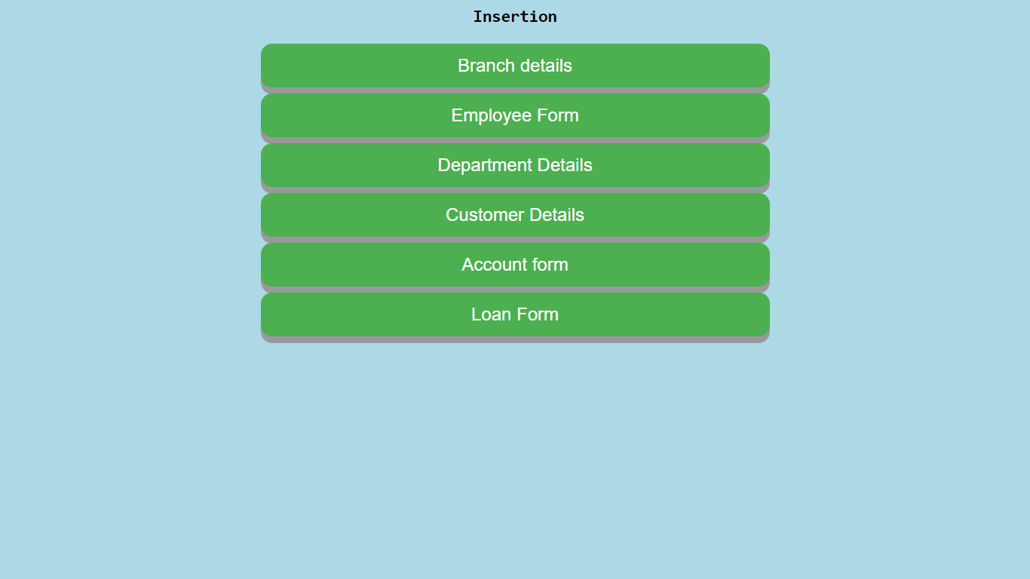

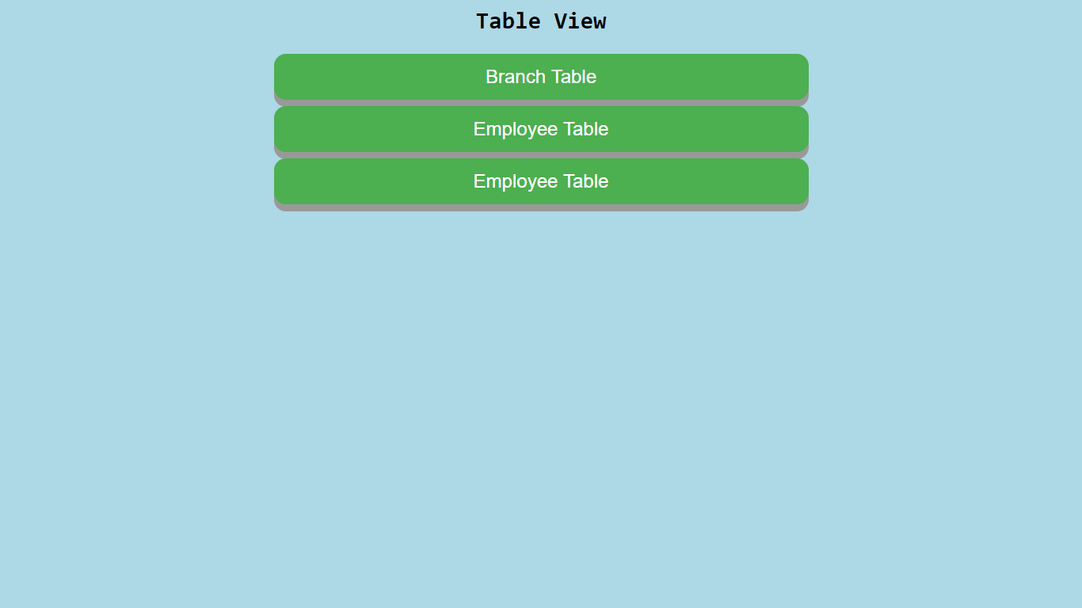

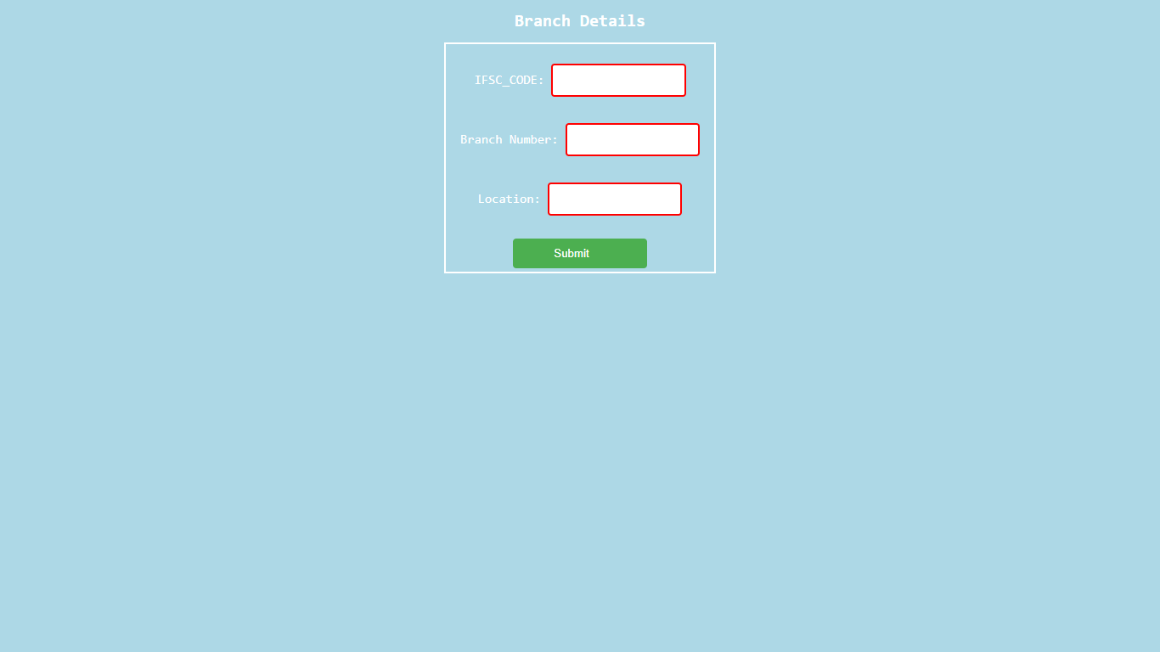

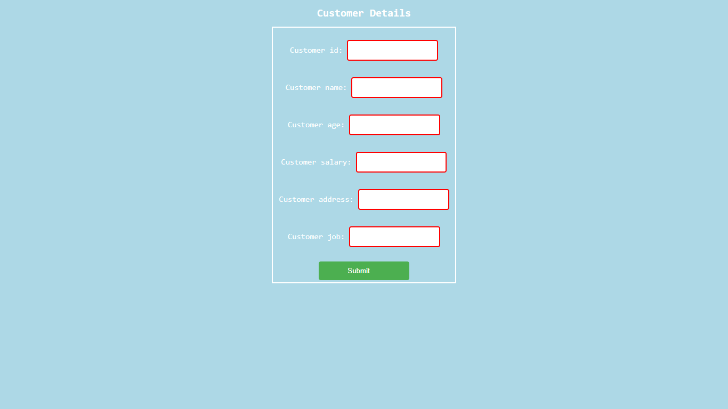

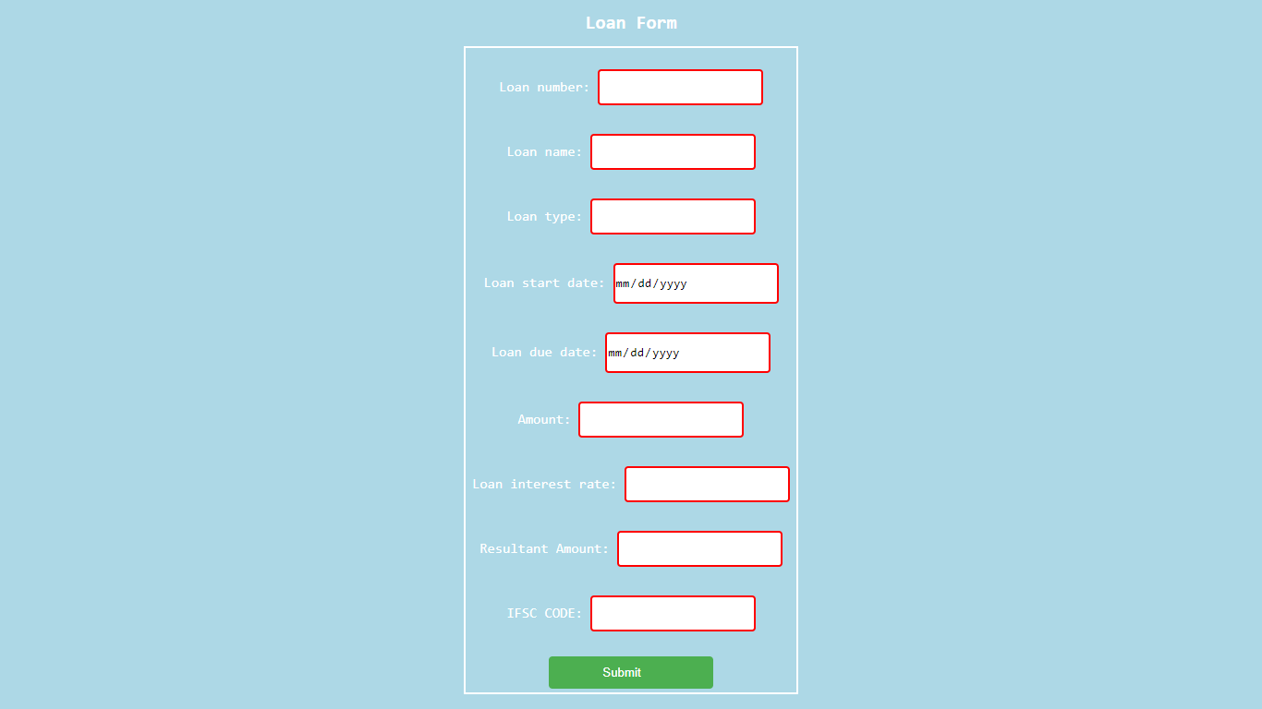

Tables

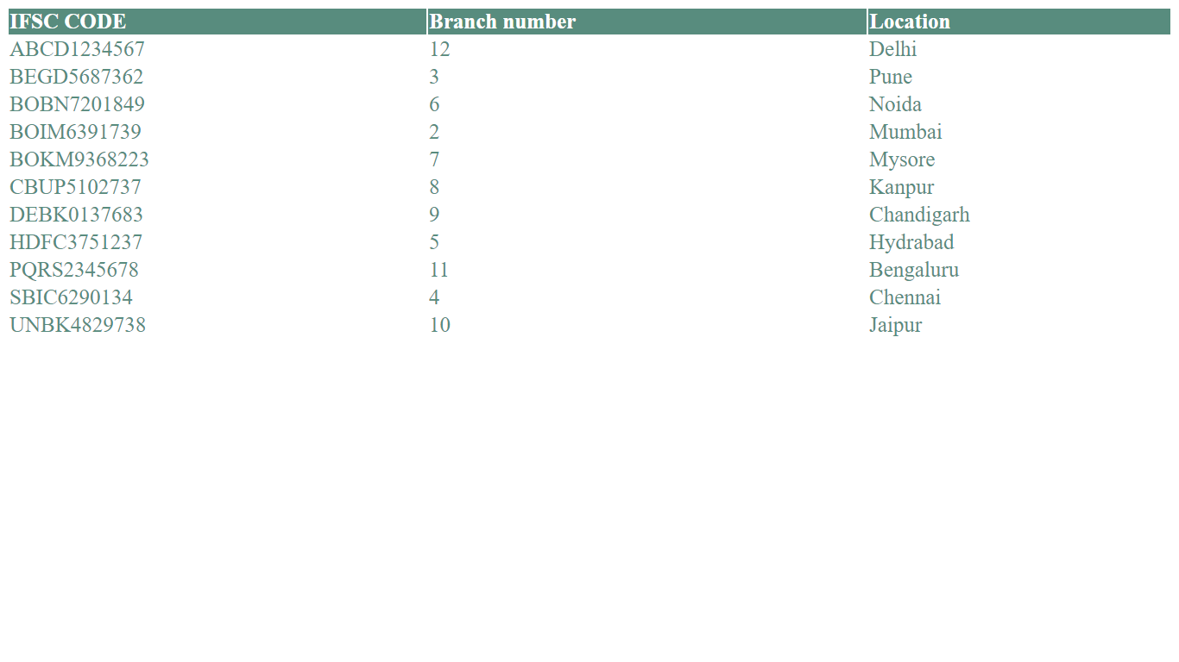

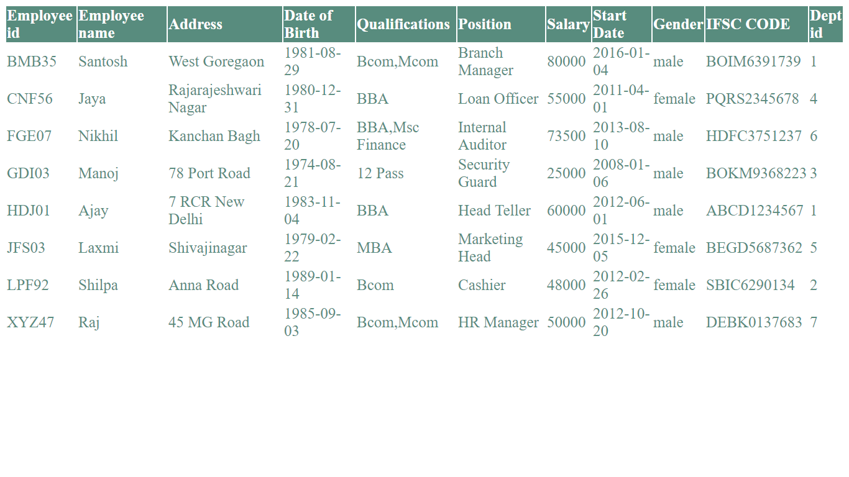

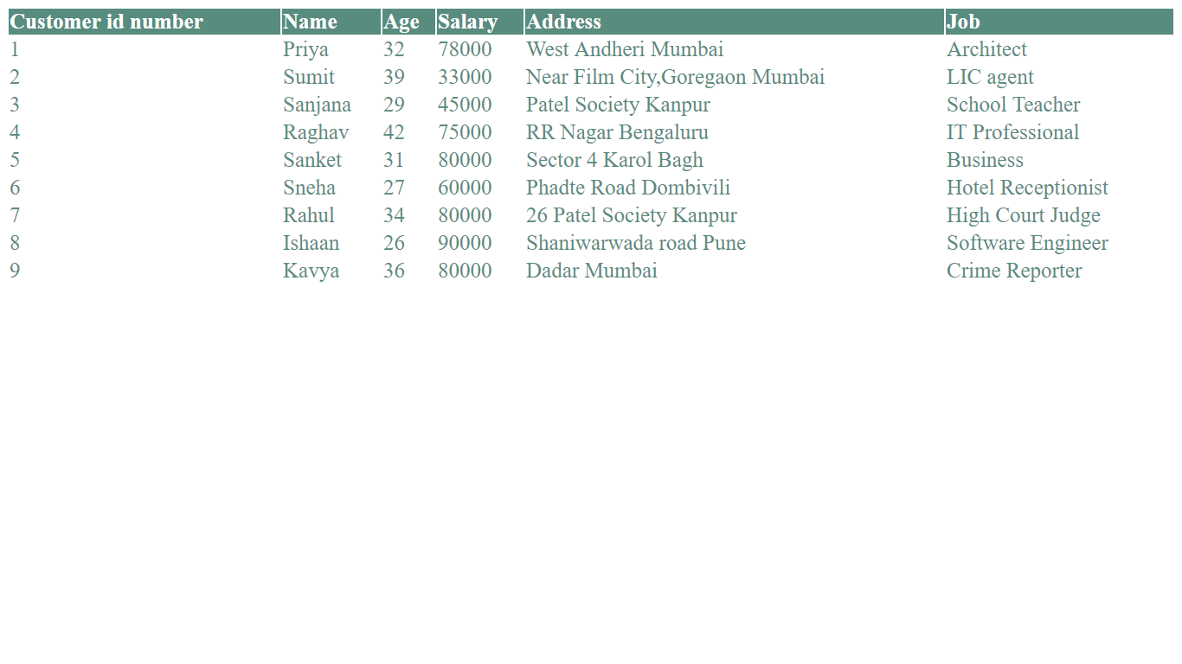

Simple SQL Queries

INSERT Statements-

INSERT INTO BRANCH VALUES('GIRS9879873',6,'Pune');

INSERT INTO EMPLOYEE VALUES('SQA50','Neha','78 Port Road','1984-03-09','BBA,Mcom','Head Teller',55000,'2013-06-16','Female','BOIA9921461',7);

INSERT INTO EMPLOYEE_PAST_JOBS('HMS79','Regional Head');

INSERT INTO DEPARTMENT VALUES('002','Account','Ground Floor');

INSERT INTO CUSTOMER VALUES(20,'Tanmay',28,56000,'Bagmari Road Ghosh Bagan Kolkata','Architect');

INSERT INTO ACCOUNT VALUES('RD0000000001','Raj','Recurring Deposit',28400,'2009-12-31','6.00%','BOBM9023947');

INSERT INTO CUSTOMER_ACCOUNT VALUES(2,'FD0000000001');

INSERT INTO LOAN VALUES('CRED000001','Vinay','Credit Card loan','2018-04-01','2018-10-01',50000,'15%',53750,'DLTM738275O');

INSERT INTO CUSTOMER_LOAN VALUES(11,'CRED000001');

ALTER statements-

ALTER TABLE EMPLOYEE ALTER COLUMN POSITION TYPE VARCHAR(15);

ALTER TABLE CUSTOMER DROP COLUMN CUSTOMER_AGE;

ALTER TABLE EMPLOYEE MODIFY DATE_OF_BIRTH DATE NOT NULL;

ALTER TABLE CUSTOMER_LOAN DROP CONSTRAINT customer_loan_customer_customer_id_number_fkey;

DELETE statements-

DELETE FROM CUSTOMER_ACCOUNT WHERE CUST_ID_NUMBER=2;

DELETE FROM EMPLOYEE WHERE em_id='HAB93';

DELETE FROM CUSTOMER_LOAN CASCADE;

UPDATE statements-

UPDATE LOAN SET loan_type='Home Loan' WHERE name='Vinay';

UPDATE EMPLOYEE SET address='7th Block Indiranagar' WHERE em_id='ABC01';

UPDATE ACCOUNT SET interest_rate='4.50%' WHERE account_type='Savings Account';

UPDATE DEPARTMENT SET location='First Floor' WHERE department name='Loan';

Complex SQL Queries

1)

SELECT customer_name,customer_age

FROM customer

WHERE NOT(EXISTS(SELECT cust_id_number

FROM customer_account

WHERE customer_id_number=cust_id_number)

OR

EXISTS(SELECT c_id_number

FROM customer_loan

WHERE customer_id_number=c_id_number));

2)

SELECT AVG(customer_salary) AS Salary,AVG(loan_amount) AS Loan_Amount

FROM customer as C,Loan AS L

WHERE C.customer_name IN( SELECT L.name

FROM LOAN

WHERE C.customer_name=L.name AND C.customer_salary>=50000);

3)

SELECT account_name,AVG(account_balance),count(*) AS no_of_accounts

FROM ACCOUNT

WHERE account_balance>=50000

GROUP BY account_name

HAVING count(*)>1;

4)

SELECT em_name,address,date_of_birth,salary

FROM EMPLOYEE

Where (SELECT COUNT(*)

FROM EMPLOYEE_PAST_JOBS

WHERE employee_id=em_id)>=2;

5)

SELECT em_id,em_name,salary,gender,branch_location

FROM (EMPLOYEE JOIN BRANCH ON ifsc=ifsc_code)

WHERE branch_location LIKE 'Delhi' OR branch_location LIKE 'Mumbai';

6)

SELECT customer_name,customer_age,account_type,account_balance

FROM ((CUSTOMER LEFT OUTER JOIN ACCOUNT ON customer_name=account_name) LEFT OUTER JOIN CUSTOMER_ACCOUNT ON customer_account_number=cust_account_number)

WHERE start_date<='2011-10-10';

7)

SELECT customer_name,customer_address,loan_type,loan_amount,branch_location

FROM (((LOAN LEFT OUTER JOIN CUSTOMER ON name=customer_name) JOIN BRANCH ON ifsc_=ifsc_code) JOIN CUSTOMER_LOAN ON loan_number=l_number)

WHERE branch_location IN( SELECT branch_location

FROM BRANCH

WHERE branch_location <>'Mumbai');

8)

SELECT MAX(customer_age) AS max_age,MIN(customer_age) AS min_age,MAX(customer_salary) AS max_salary,MIN(customer_salary) AS min_salary

FROM CUSTOMER

WHERE customer_name IN(SELECT account_name

FROM ACCOUNT

EXCEPT(SELECT account_name

FROM ACCOUNT

WHERE account_type='Recurring Deposit'));

9)

CREATE ASSERTION DATE_CONSTRAINT

CHECK(NOT EXISTS(SELECT *

FROM LOAN

WHERE loan_start_date>=loan_due_date));

Conclusion-

Banking system database has wide implications, applications in real life since millions of transactions occur everyday in banks around the world.Large amount of records should be stored in a systematic way in a banking system.